idx | Variable | N | Mean | Std Dev | Minimum | Lower Quartile | Median | Upper Quartile | Maximum
Control
  MPR
  Adherence
  300
  288
  0.93
  0.95
  0.10
  0.11
  0.50
  0.55
  0.83
  0.90
  1.00
  0.97
  1.00
  1.02
  1.00
  1.28
Case
  MPR
  Adherence
  158
  141
  0.95
  0.98
  0.12
  0.10
  0.17
  0.51
  0.94
  0.93
  1.00
  0.99
  1.00
  1.03
  1.00
  1.20

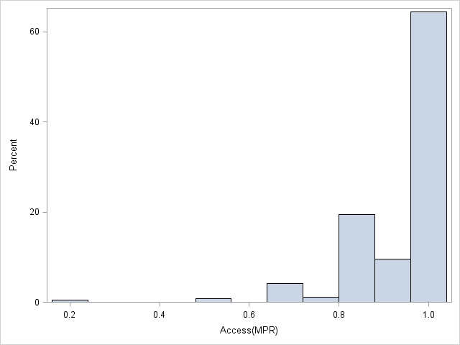
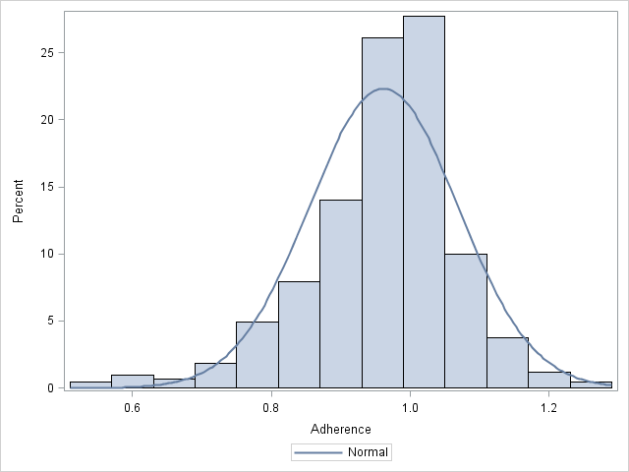
P= 0.0009 from chi-square test.

 | Control | Case | Total
Access<1
  123
  41.00
  40
  25.32
  163
Access=1
  177
  59.00
  118
  74.68
  295
Total
  300
  158
  458

